MACH4METAL

Metalworking machinery
Transito 21,
6909 DA BABBERICH, Netherlands
Tel. + 31 (0)316 – 247123
Fax. + 31 (0)316 - 247956
info@mach4metal.com
www.mach4metal.com

Account No: 66.52.13.883
IBAN : NL33 INGB 0665 2138 83
BIC : INGBNL2A

Centre hole grinder TECHNICA

- Make : TECHNICA Swiss
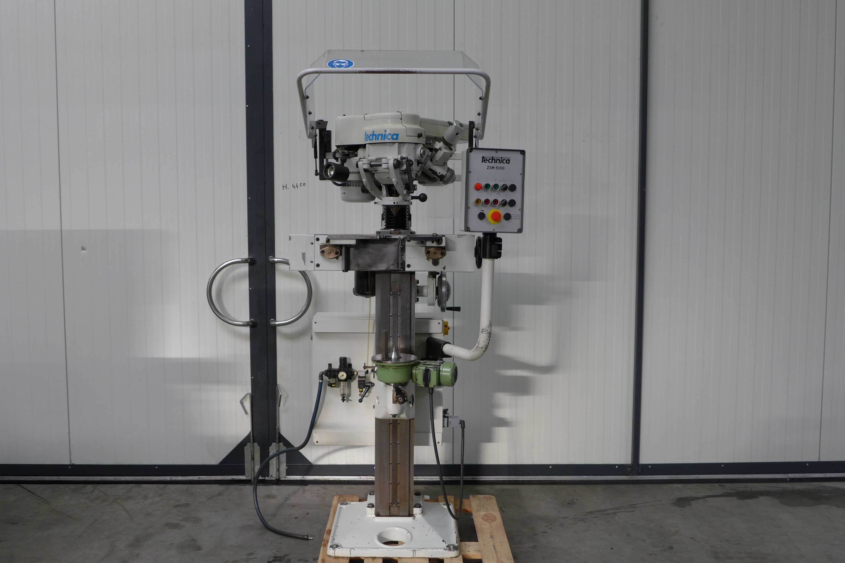
- Typ : ZSM 5100 - 810
- Mach. No : 8820 – 03 - 002
- Age : 2003

- Centre hole Ø Min : 3
- Centre hole Ø Max. : 60

- Length workpiece Min. : 50
- Length workpiece Max. : 1.100
- Workpiece weight Kg : 120
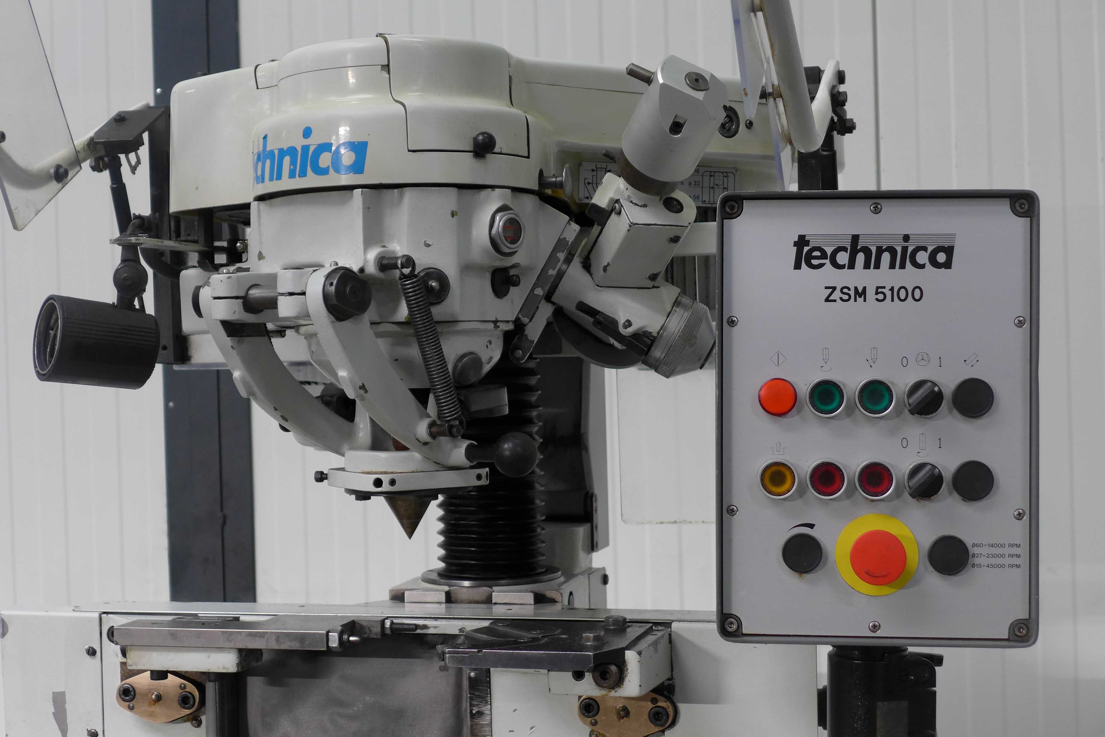

- Clamp range vice : Ø 4 - 140
- Grinding wheel spindle : Ø 32
- Ø 15 - 45.000 Rpm
- Ø 27 - 22.500 Rpm
- Ø 48 - 13.000 Rpm
- Ø 60 - 13.000 Rpm

- Grinding head adjustment : 160
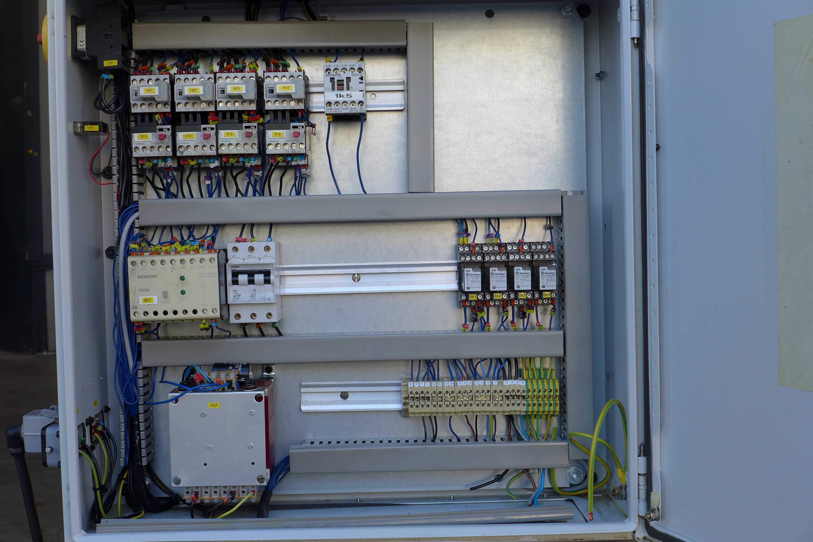
- Rapid head adjustment : 70
- Automatic dressing stroke : 40

- Adjustment : 0.01 – 0.03 mm
- Dressing speed Diamond : 470 mm/Min

- Dimensions
- Length : 967
- Width : 856
- Height : 1.850
- Weight : 700

Please Note: The above information has been obtained to the best of our ability and belief from, and from the manufacturers where possible. It is given in good faith, but its accuracy can not be guaranteed. Accordingly, it will not form a representation or constitute contractual terms. We advise you to check any vital details!

